Sponsorship Levels

Presenting Sponsor Level Top Billing: $1,500.00
- One year’s free membership in North Brunswick Chamber of Commerce
- NBCC website Business Expo recognition
- Logo recognition on all promotional materials, including:
  - Banners
  - Press releases
  - Social Media
  - Email Blasts
- Recognition on the day of the event at the ribbon cutting
- First choice of your booth location
- Logo on the Chamber Web Site promoting event with link to your website
Platinum Sponsorship Level: $1,000.00 (TAKEN)
- Opportunity to speak in all promotional interviews
- Logo recognition on all promotional materials, including:
  - Banners
  - Press releases
  - Social Media
  - Email Blasts
- Recognition on the day of the event at the ribbon cutting
- Booth space included – choice of location
- Logo and/or name on the Chamber Web Site promoting event with link to your website
Gold Sponsorship Level: $ 750.00 (TAKEN)
- Name recognition on all promotional materials, including:
  - Banners
  - Press releases
  - Social Media
  - Email Blasts
- Recognition on the day of the event at the ribbon cutting
- Booth space included – choice of location
- Name on the Chamber Web Site promoting event with link to your website
Silver Sponsorship Level: $ 500.00
- Recognition on the day of the event at the ribbon cutting
- Booth space included
- Name on the Chamber Web Site promoting event with link to your website
Bronze Sponsorship Level: $ 250.00
- Booth Space Included
- Name on the Chamber Web Site promoting event with link to your website

497 Olde Waterford Way · Suite 202 · Belville, NC 28451 · 910-383-0553 Office · 910-383-1992 Fax
nbchamber@nbchamber.net www.nbchamberofcommerce.com
Sustaining Sponsors
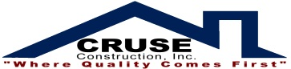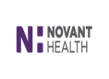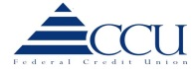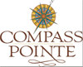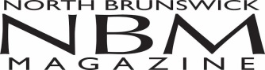
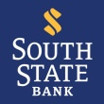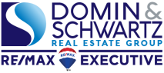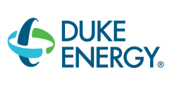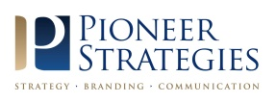

This event has continued to grow year after year, as our community continues to expand and become more involved. In 2023, we’re focusing on bringing in EVEN MORE exhibitors and ramping up heavy promotion to the public. The goal of this event is to promote our local business community and encourage our community to ‘shop local’. We would love to see your company name on the sponsor list.

Your sponsorship will appear in our promotional efforts in a wide variety of media, such as:
- Radio and TV
- NBCC Website
- Social Media
- Press Releases
- Email Blasts

Please call the Chamber office if you have any questions about booth space or sponsorship opportunities
910-383-0553.

YES, count on our support for the 2023 Business Expo.

_____ Presenting $1,500.00
_____ Platinum $1,000.00
_____ Gold $ 750.00
_____ Silver $ 500.00
_____ Bronze $ 250.00

Company Name: ________________________________________ Signature: ______________________
Address: ______________________________________________ Date: __________________________
______________________________________________
Telephone: ____________________________________________ Fax: ___________________________
E-mail: _______________________________________________

Check Enclosed: _______________________________________

497 Olde Waterford Way · Suite 202 · Belville, NC 28451 · 910-383-0553 Office · 910-383-1992 Fax
northbrunswickchamber@gmail.com www.nbchamberofcommerce.com

Sustaining Sponsors
